MGT 40750 – Quantitative Decision Modeling Spring 2017

**Assignment 4: Spreadsheet Simulation Using @Risk**

***Due Date: 03/06/2017 (Monday)***

**Name(s): ______________________________________________________**

*Make sure all your group members (no more than 3) sign here.*

There are three questions (15 total points) in this assignment. All relevant Excel files can be found on Sakai. Solve these questions in Excel and fill in the solution template provided below.

For questions related to @Risk, it will probably help to review what we did in class by reading pages 561-572 in the Practical Management Science 5th Ed textbook in the text where the @Risk features are discussed. I think it will be easiest to go find a PC on campus to use @Risk. It can be found by clicking on the Start button, then All Programs, then Palisade Decision Tools, then @Risk. This will launch Excel and @Risk at the same time. You will then find the @Risk menu.

**Question 1: Investing for retirement (Retirement.xlsx)**

Consider a variation of the investing for retirement example we discussed in class and implement the following strategy:

* invest at mean 8%, standard deviation 25% if balance is < $700,000;
* invest at mean 5%, standard deviation 15% if balance is >= $700,000 and < $1,000,000;
* stop investing if balance is >= $1,000,000.

*a. Specify the following @Risk Model in Excel:*

|  |
| --- |
|  |
| … |
|  |

*b. Report the mean and standard deviation of the ending balance after 30 years.*

Mean = ____________

Standard deviation = ____________

*c. What is the probability that the ending balance is >= $1,000,000?* (You get the probability by looking at the detailed statistics output and typing in 1,000,000 into a “target value” cell in the column corresponding to the ending balance. See page 593-594 of the text.)

Prob (the ending balance >= $1,000,000) = ____________

*d. Compare the strategy you analyzed in this problem to the strategy we discussed in class (Model 3: invest at 8% if balance is <$1,000,000 and stop investing if balance is >=$1,000,000).* Suppose Amanda’s investment target is to achieve an ending balance of $1,000,000. Which strategy would you recommend? Why?

____________________________________________________________________________________________________________________________________________________________________________________________________________________________________________________________________________________________________________________________________________________________________________________________________________________________________________________________________________________

**Question 2: Doubling strategy in Roulette (Roulette.xlsx)**

Suppose you have $100 at the beginning and you decide to bet on Red in Roulette.

Simulate the following *doubling* strategy. You begin by betting $1. Each subsequent bet is decided as follows: If you won the last bet, you again bet $1. If you lost the last bet, you bet twice the previous bet, if you have enough money. Otherwise, you return to betting $1 unless you’ve run out.

*a. Specify the following @Risk Model in Excel:*

|  |
| --- |
|  |
| … |
|  |

*b*. Define *Final Winning* as the winning after 100 rounds of betting. If your money runs out before 100 rounds, then the winnings remain zero.

*What’s the probability of losing all your initial $100?*

*What’s the probability of getting a final winning of $150 or more?*

**Question 3: When to pull the goalie in hockey (Hockey.xlsx)**

Consider a variation of the hockey example we discussed in class and implement the following strategy: Pull your goalie if you are behind at any point in the last *three minutes* of the game; put him back in if you tie the score.

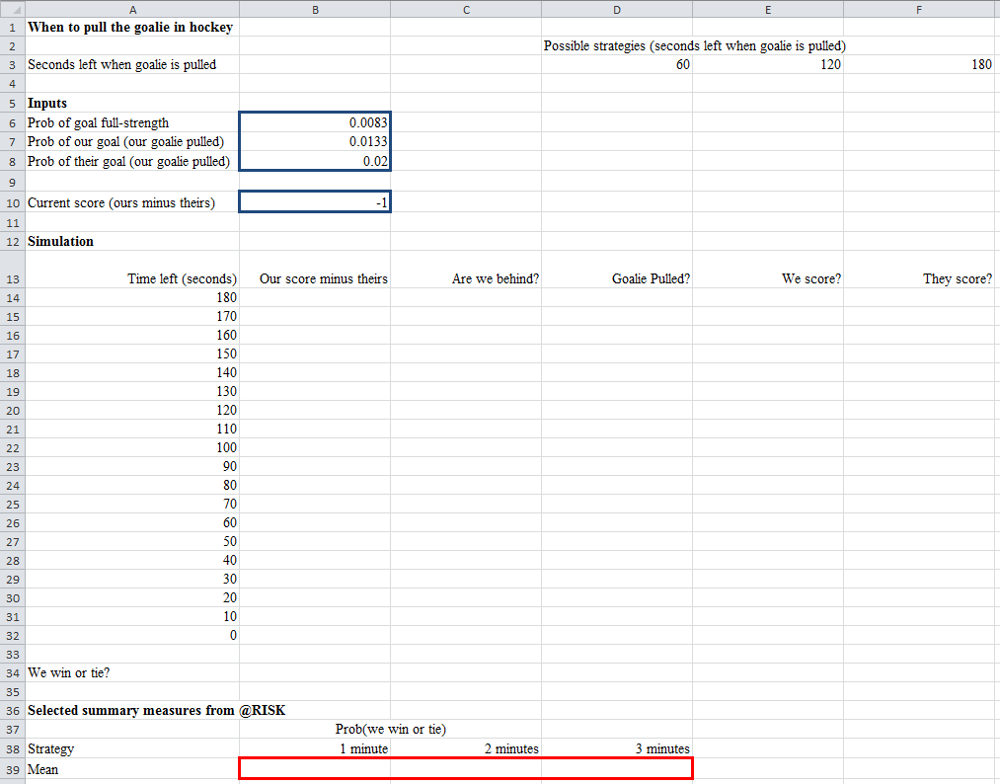*a. Specify the following @Risk Model in Excel:*

*b. What’s the probability that we win or tie?*

